**LAB #1**

* **F1 = A’B’C+A’B’C+A’BC+ABC’+ABC+A’B’+BC’+AB**

**= A’B’C+BC+ABC’+A’B’+AB+BC’**

**= A’B’(C+1) + B(C+C’) + AB(C’+1)**

**= A’B’ + B + AB**

1. TRUTH TABLE

|  |  |  |  |  |
| --- | --- | --- | --- | --- |
| A | B | A’B’ | AB | F1 |
| 0 | 0 | 1 | 0 | 1 |
| 0 | 1 | 0 | 0 | 1 |
| 1 | 0 | 0 | 0 | 0 |
| 1 | 1 | 0 | 1 | 1 |

1. CIRCUIT DIAGRAM BY USING BASIC GATES (NOT, OR, AND).

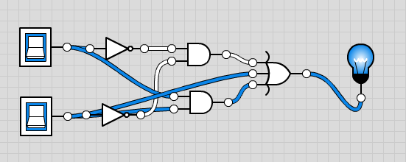

1. Circuit diagram by using universal gates ( nand ).

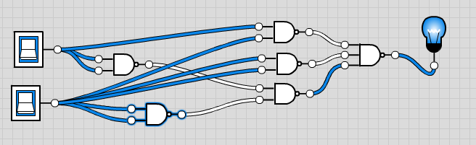

1. Circuit diagram by using universal gates ( NOR ).

* **F2 = A’B’C’D+AB’C’D+A’BC’D+ABC’D+A’BCD+ABCD**

**= B’C’D(A’+A)+BC’D(A’+A)+BCD(A’+A)**

**= B’C’D + BC’D + BCD**

**= C’D(B’+B)+BCD**

**= C’D + BCD**

1. TRUTH TABLE

|  |  |  |  |  |  |  |
| --- | --- | --- | --- | --- | --- | --- |
| B | C | D | C’ | C’D | BCD | F2 = **C’D + BCD** |
| 0 | 0 | 0 | 1 | 0 | 0 | 0 |
| 0 | 0 | 1 | 1 | 1 | 0 | 1 |
| 0 | 1 | 0 | 0 | 0 | 0 | 0 |
| 0 | 1 | 1 | 0 | 0 | 0 | 0 |
| 1 | 0 | 0 | 1 | 0 | 0 | 0 |
| 1 | 0 | 1 | 1 | 1 | 0 | 1 |
| 1 | 1 | 0 | 0 | 0 | 0 | 0 |
| 1 | 1 | 1 | 0 | 0 | 1 | 1 |

1. CIRCUIT DIAGRAM BY USING BASIC GATES (NOT, OR, AND).

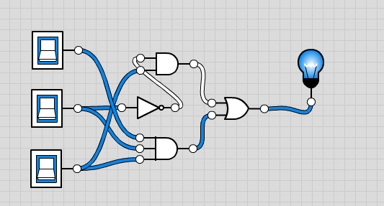

1. Circuit diagram by using universal gates ( nand ).

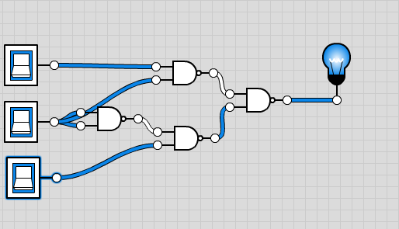

* **F3 = AB + A’BC’D + A’BCD + AB’C’D**

**= AB+ D(A’BC+AB’C’)+A’BCD**

**= AB+D+A’BCD**

**= AB+D(1+A’BCD)**

**= AB + D**

|  |  |  |  |  |
| --- | --- | --- | --- | --- |
| A | B | D | AB | D |
| 0 | 0 | 0 | 0 | 0 |
| 0 | 0 | 1 | 0 | 1 |
| 0 | 1 | 0 | 0 | 0 |
| 0 | 1 | 1 | 0 | 1 |
| 1 | 0 | 0 | 0 | 0 |
| 1 | 0 | 1 | 0 | 1 |
| 1 | 1 | 0 | 1 | 1 |
| 1 | 1 | 1 | 1 | 1 |

1. CIRCUIT DIAGRAM BY USING BASIC GATES (NOT, OR, AND).

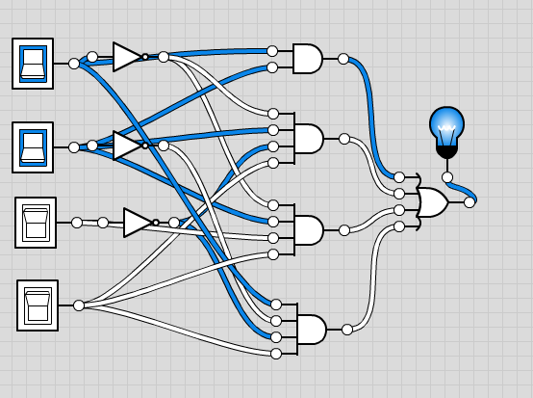

|  |  |  |  |
| --- | --- | --- | --- |
| X | Y | Z | F4 |
| 0 | 0 | 0 | 0 |
| 0 | 0 | 1 | 1 |
| 0 | 1 | 0 | 1 |
| 0 | 1 | 1 | 1 |
| 1 | 0 | 0 | 1 |
| 1 | 0 | 1 | 0 |
| 1 | 1 | 0 | 1 |
| 1 | 1 | 1 | 1 |

1. CIRCUIT DIAGRAM BY USING BASIC GATES (NOT, OR, AND).

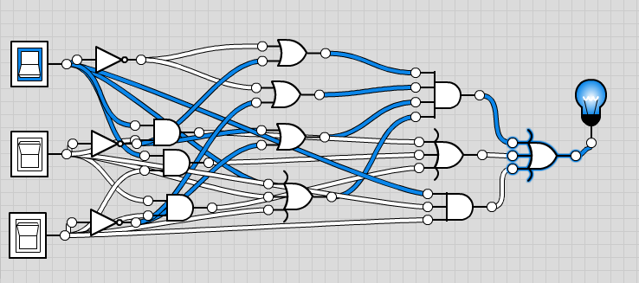

1. diagram by using universal gates ( nand ).

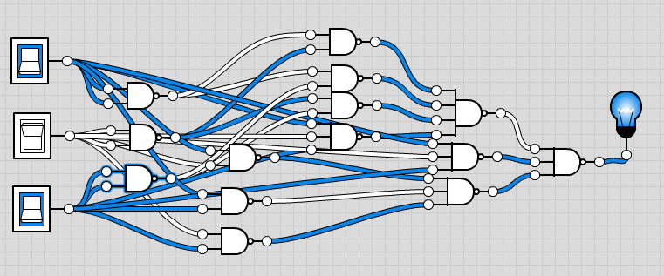

|  |  |  |  |  |  |  |  |
| --- | --- | --- | --- | --- | --- | --- | --- |
| A | B | C | D | X | Y | Z | F5 |
| 0 | 0 | 0 | 0 | 0 | 0 | 0 | 0 |
| 0 | 0 | 0 | 0 | 0 | 0 | 1 | 1 |
| 0 | 0 | 0 | 0 | 0 | 1 | 0 | 1 |
| 0 | 0 | 0 | 0 | 0 | 1 | 1 | 1 |
| 0 | 0 | 0 | 0 | 1 | 0 | 0 | 1 |
| 0 | 0 | 0 | 0 | 1 | 0 | 1 | 1 |
| 0 | 0 | 0 | 0 | 1 | 1 | 0 | 1 |

2 CIRCUIT DIAGRAM BY USING BASIC GATES (NOT, OR, AND).

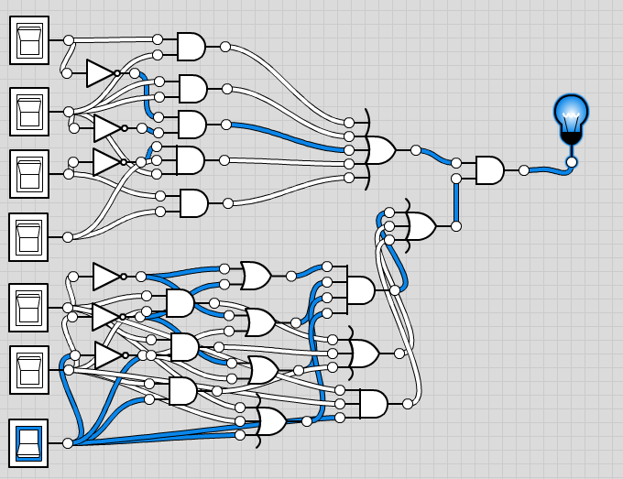

**Lab 2-3**

**F1 = A’B’+AB’C+’BC+AB’+C+AB’+C’+AB**

|  |  |  |  |
| --- | --- | --- | --- |
| **A** | **B** | **C** | **OUTPUT** |
| **0** | **0** | **0** | **1** |
| **0** | **0** | **1** | **1** |
| **0** | **1** | **0** | **1** |
| **0** | **1** | **1** | **1** |
| **1** | **0** | **0** | **1** |
| **1** | **0** | **1** | **1** |
| **1** | **1** | **0** | **1** |
| **1** | **1** | **1** | **1** |

2 CIRCUIT DIAGRAM BY USING BASIC GATES (NOT, OR, AND).

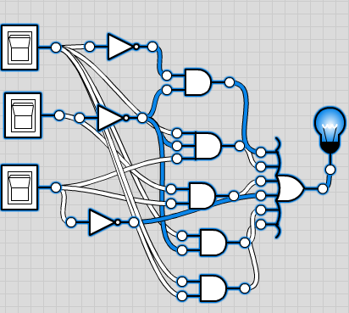

1. Circuit diagram by using universal gates ( nand ).

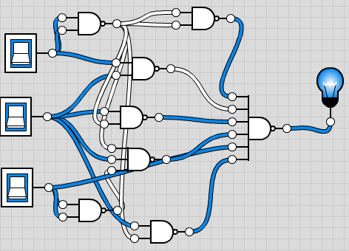

STANDARD FORM IN THE FORM OF SUM OF MINTERMS:

**F1 = A’B’C’ + A’B’C + A’BC + AB’C’ + A’BC + AB’C + ABC’ + ABC**

**CIRCIUT DIAGRAM FOR SUM OF MINTERMS**

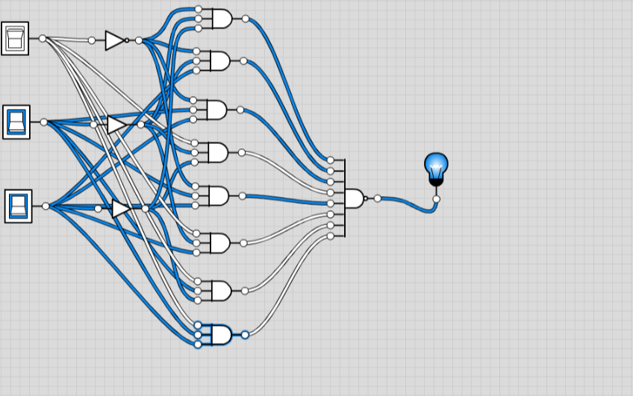

STANDARD FORM IN THE FORM OF PRODUC OF MAX-TERMS:

F1 = (A’ + B + C’)

**CIRCUIT DIAGRAM FOR PRODUCT OF MAX TERM**

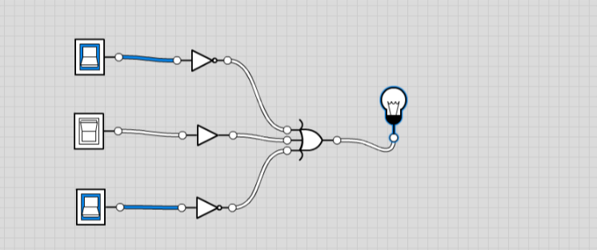

* **F2 = AB’C’D+ABC’+C’D+BC’D+A’B+AD**

**= AD(B’C’ +1)+C’D(1+B)+A’B+ABC’**

**= AD + C’D + A’B + ABC’**

1. **TRUTH TABLE**

|  |  |  |  |  |
| --- | --- | --- | --- | --- |
| **A** | **B** | **C** | **D** | **F2** |
| 0 | 0 | 0 | 0 | 0 |
| 0 | 0 | 0 | 1 | 1 |
| 0 | 0 | 1 | 0 | 0 |
| 0 | 0 | 1 | 1 | 0 |
| 0 | 1 | 0 | 0 | 1 |
| 0 | 1 | 0 | 1 | 1 |
| 0 | 1 | 1 | 0 | 1 |
| 0 | 1 | 1 | 1 | 1 |
| 1 | 0 | 0 | 0 | 0 |
| 1 | 0 | 0 | 1 | 1 |
| 1 | 0 | 1 | 0 | 0 |
| 1 | 0 | 1 | 1 | 1 |
| 1 | 1 | 0 | 0 | 0 |
| 1 | 1 | 0 | 1 | 1 |
| 1 | 1 | 1 | 0 | 0 |
| 1 | 1 | 1 | 1 | 1 |

1. CIRCUIT DIAGRAM BY USING BASIC GATES (NOT, OR, And)

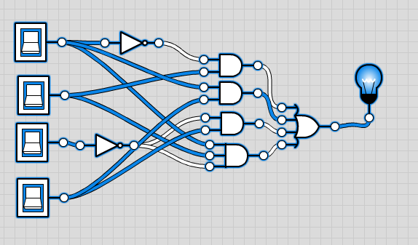

1. Circuit diagram by using universal gates ( nand ).

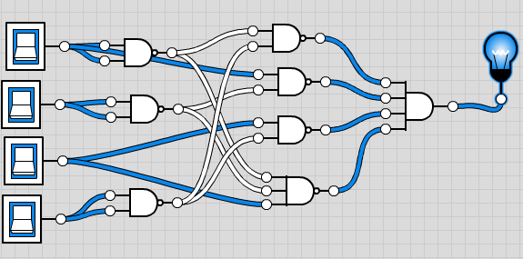

STANDARD FORM IN THE FORM OF SUM OF MINTERMS:

F2 = A’BC’D’ + A’BC’D’ + A’BC’D + A’BCD’ + A’BCD +AB’C’D + AB’CD’ + AB’CD + ABC’D’ + ABC’D + ABCD’ + ABCD

**CIRCUIT DIAGRAM FOR SUM OF MINTERMS:**

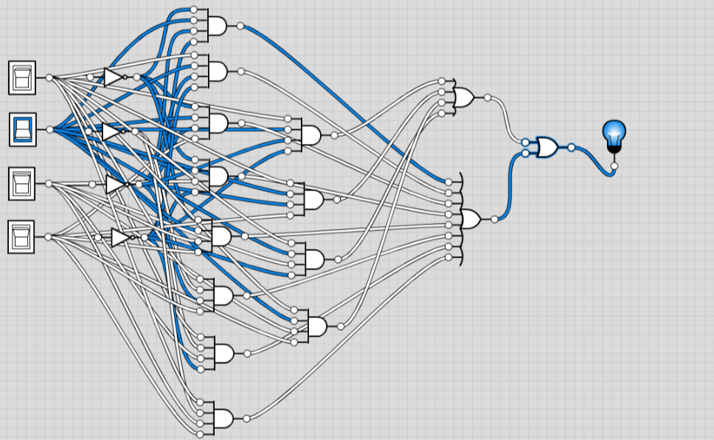

**STANDARD FORM IN THE FORM OF PRODUC OF MAX-TERMS:**

F2 = (A’+B’+C’+D’)(A’+B’+C’+D)(A’+B’+C+D’)(A’+B’+C+D)(A+B’+C’+D’)

**CIRCUIT DIAGRAM FOR PRODUCT OF MAX TERMS**

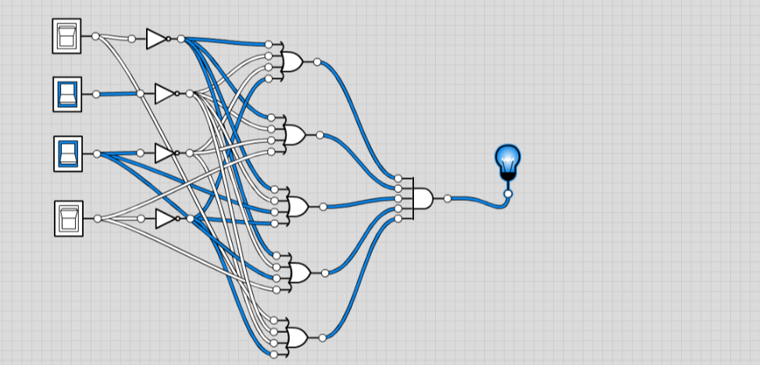

**F3 = AB+A’B’D+A’B+AB’C’D**

|  |  |  |  |  |
| --- | --- | --- | --- | --- |
| A | B | C | D | F3 |
| 0 | 0 | 0 | 0 | 0 |
| 0 | 0 | 0 | 1 | 0 |
| 0 | 0 | 1 | 0 | 1 |
| 0 | 0 | 1 | 1 | 1 |
| 0 | 1 | 0 | 0 | 1 |
| 0 | 1 | 0 | 1 | 1 |
| 0 | 1 | 1 | 0 | 1 |
| 0 | 1 | 1 | 1 | 1 |
| 1 | 0 | 0 | 0 | 0 |
| 1 | 0 | 0 | 1 | 1 |
| 1 | 0 | 1 | 0 | 0 |
| 1 | 0 | 1 | 1 | 0 |
| 1 | 1 | 0 | 0 | 1 |
| 1 | 1 | 0 | 1 | 1 |
| 1 | 1 | 1 | 0 | 1 |
| 1 | 1 | 1 | 1 | 1 |

**CIRCUIT DIAGRAM FOR EQUATION:**

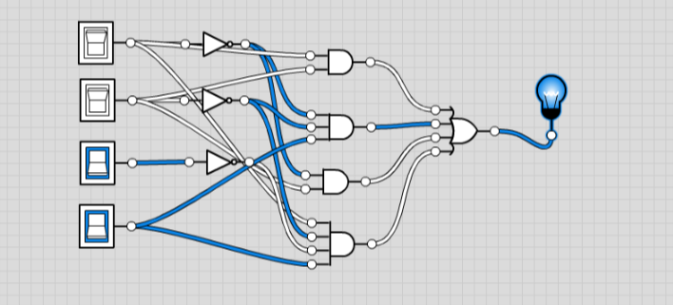

STANDARD FORM IN THE FORM OF SUM OF MINTERMS:

F3 = A’B’CD’+A’B’CD+A’BC’D’+A’BC’D+A’BCD+AB’C’D+A’BCD+AB’C’D+ABC’D’+ABC’D+ABCD’+ABCD

**CIRCUIT DIAGRAM FOR SUM OF MIN TERMS:**

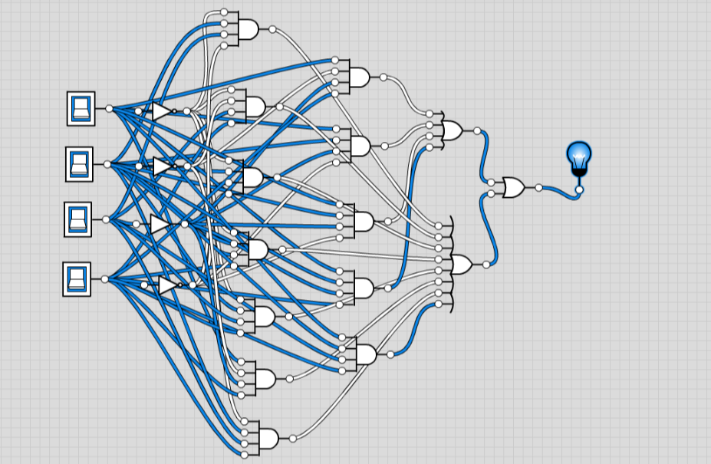

**STANDARD FORM IN THE FORM OF PRODUC OF MAX-TERMS:**

F3 = (A’+B’+C’+D’)(A’+B’+C’+D)(A+B’+C’+D’)(A+B’+C+D’)(A+B’+C+D)

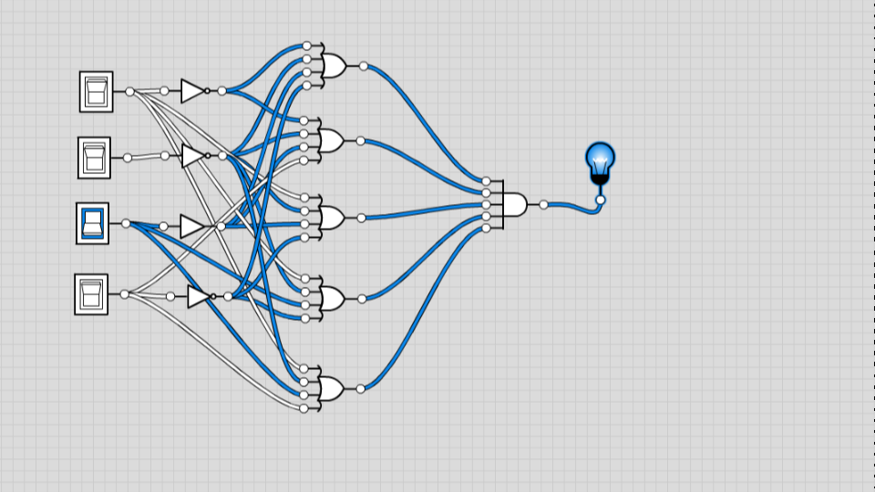

* **F4 = C + S where C = xy + yz and S = C’ (x + y) + xyz**

**C = XY + YZ**

**C’ = (XY + YZ)’**

**XY + YZ + (XY + YZ)’(X + Y)+ XYZ**

**XY + YZ + (X’ + Y’)(Y’ + Z’)(X + Y) + XYZ**

**XY + YZ +(Y’ + X’ )(Y’ + Z’)(X + Y) + XYZ**

**XY + YZ +Y’ + X’Z’ (X + Y)+ XYZ**

**F4 = XY + YZ + Y’+XYZ’ + XYZ**

|  |  |  |  |
| --- | --- | --- | --- |
| X | Y | Z | OUTPUT |
| 0 | 0 | 0 | 1 |
| 0 | 0 | 1 | 1 |
| 0 | 1 | 0 | 0 |
| 0 | 1 | 1 | 0 |
| 1 | 0 | 0 | 1 |
| 1 | 0 | 1 | 1 |
| 1 | 1 | 0 | 1 |
| 1 | 1 | 1 | 1 |

**CIRCUIT DIAGRAM FOR EQUATION**

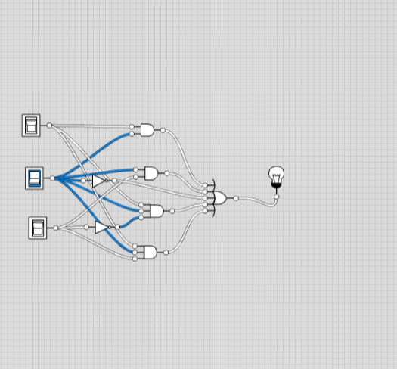

STANDARD FORM IN THE FORM OF SUM OF MINTERMS:

**F4 = X’Y’Z’ + X’Y’Z + X’YZ’ + X’YZ + XY’Z’ + XY’Z + XYZ’ + XYZ**

**CIRCUIT DIAGRAM FOR STANDARD FORM**

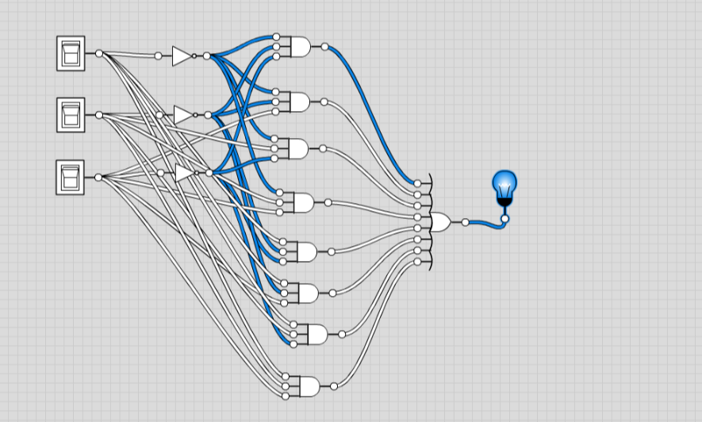

**LAB 4-5**

* **F1 = A’B’+AB’C+A’BC+AB’+C+AB’+C’+AB**

1. **TRUTH TABLE**

|  |  |  |  |
| --- | --- | --- | --- |
| **A** | **B** | **C** | **F1** |
| **0** | **0** | **0** | **1** |
| **0** | **0** | **1** | **1** |
| **0** | **1** | **0** | **1** |
| **0** | **1** | **1** | **1** |
| **1** | **0** | **0** | **1** |
| **1** | **0** | **1** | **1** |
| **1** | **1** | **0** | **1** |
| **1** | **1** | **1** | **1** |

1. **SIMPLIFY THE FUNCTION THROUGH K MAP.**

|  |  |  |  |
| --- | --- | --- | --- |
| **1** | **1** | **1** | **1** |
| **1** | **1** | **1** | **1** |
| **1** | **1** | **1** | **1** |
| **1** | **1** | **1** | **1** |

**F1 = 1**

* **F2 = AB’C’D+AC’D+C’D+C’D+A’B+AD**

1. **TRUTH TABLE**

|  |  |  |  |  |
| --- | --- | --- | --- | --- |
| **A** | **B** | **C** | **D** | **F2** |
| **0** | **0** | **0** | **0** | **0** |
| **0** | **0** | **0** | **1** | **1** |
| **0** | **0** | **1** | **0** | **0** |
| **0** | **0** | **1** | **1** | **0** |
| **0** | **1** | **0** | **0** | **1** |
| **0** | **1** | **0** | **1** | **1** |
| **0** | **1** | **1** | **0** | **1** |
| **0** | **1** | **1** | **1** | **1** |
| **1** | **0** | **0** | **0** | **0** |
| **1** | **0** | **0** | **1** | **1** |
| **1** | **0** | **1** | **0** | **0** |
| **1** | **0** | **1** | **1** | **1** |
| **1** | **1** | **0** | **0** | **0** |
| **1** | **1** | **0** | **1** | **1** |
| **1** | **1** | **1** | **0** | **0** |
| **1** | **1** | **1** | **1** | **1** |

1. **SIMPLIFY THE FUNCTION THROUGH K MAP.**

|  |  |  |  |
| --- | --- | --- | --- |
| **0** | **1** | **0** | **0** |
| **1** | **1** | **1** | **1** |
| **0** | **1** | **1** | **0** |
| **0** | **1** | **1** | **0** |

**F2 = C’D + A’B + AD**

1. **2-LEVEL NAND GATE:**

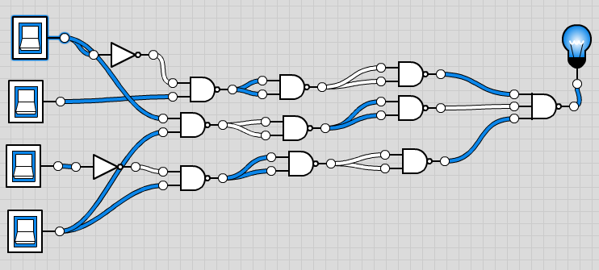

* **F3 = AB + A’C’D + A’BD + AB’C’**

1. **TRUTH TABLE**

|  |  |  |  |  |
| --- | --- | --- | --- | --- |
| **A** | **B** | **C** | **D** | **F3** |
| **0** | **0** | **0** | **0** | **0** |
| **0** | **0** | **0** | **1** | **1** |
| **0** | **0** | **1** | **0** | **0** |
| **0** | **0** | **1** | **1** | **0** |
| **0** | **1** | **0** | **0** | **0** |
| **0** | **1** | **0** | **1** | **1** |
| **0** | **1** | **1** | **0** | **0** |
| **0** | **1** | **1** | **1** | **1** |
| **1** | **0** | **0** | **0** | **1** |
| **1** | **0** | **0** | **1** | **1** |
| **1** | **0** | **1** | **0** | **0** |
| **1** | **0** | **1** | **1** | **0** |
| **1** | **1** | **0** | **0** | **1** |
| **1** | **1** | **0** | **1** | **1** |
| **1** | **1** | **1** | **0** | **1** |
| **1** | **1** | **1** | **1** | **1** |

1. **SIMPLIFY THE FUNCTION THROUGH K MAP.**

|  |  |  |  |
| --- | --- | --- | --- |
| **0** | **1** | **0** | **0** |
| **0** | **1** | **0** | **0** |
| **0** | **1** | **1** | **0** |
| **1** | **1** | **1** | **1** |
| **1** | **1** | **0** | **0** |

**F3 = AB + A’C’D + AB’C’ + A’BD**

* **F4 = C + S where C = XY +YZ and**

**S = C’(X+Y)+XYZ**

**S = (X’+Y’)(Y’+Z’)(X+Y)+XYZ**

**S = X’Y’+XZ’+Y’Y’+Y’Z’(X+Y)+XYZ**

**S = XY’+XZ’+XY’+XY’Z’+X’Y+X’Y’Z+Y+YZ’**

**S = XY’ + XZ’+ XY’**

**F4 = (XY + YZ)+ XYZ**

**1 TRUTH TABLE**

|  |  |  |  |
| --- | --- | --- | --- |
| **X** | **Y** | **Z** | **OUTPUT** |
| **0** | **0** | **0** | **0** |
| **0** | **0** | **1** | **0** |
| **0** | **1** | **0** | **0** |
| **0** | **1** | **1** | **1** |
| **1** | **0** | **0** | **0** |
| **1** | **0** | **1** | **0** |
| **1** | **1** | **0** | **1** |
| **1** | **1** | **1** | **1** |

1. **TRUTH TABLE**

|  |  |  |  |
| --- | --- | --- | --- |
| **X** | **Y** | **Z** | **F4** |
| **0** | **0** | **0** | **0** |
| **0** | **0** | **1** | **0** |
| **0** | **1** | **0** | **1** |
| **0** | **1** | **1** | **1** |
| **1** | **0** | **0** | **1** |
| **1** | **0** | **1** | **1** |
| **1** | **1** | **0** | **1** |
| **1** | **1** | **1** | **1** |

1. **SIMPLIFY THE FUNCTION THROUGH K MAP.**

|  |  |  |  |
| --- | --- | --- | --- |
| **0** | **1** | **1** | **1** |
| **1** | **1** | **1** | **1** |

**F4 = X + Y’Z + Y’**